Half-Yearly Progress Report for Jan-May/July-NOV 20xx

# Data sheet for PhD scholars

**Name:** Shuvrajeet Das

**Registration No.:** DA24D402

**Department:** Data Science and Artificial Intelligence

**Date of Joining:** 01-07-2024

**Date of Upgradation (if any):**

**Specialization / Stream:** Reinforcement Learning

**Area of Research Work:** Reinforcement Learning in Sensing

**Category of Admission (Regular/Part-Time/External…):** Regular

**Guide:** Chandrashekar Lakshminarayanan

**Co-Guide(s) (if any):**

# Date of DC Meetings:

|  |  |  |
| --- | --- | --- |
| **Description** | **Event** | **Date** |
| 0th DC Meeting | Prescription of coursework | 01-07-2024 |
| 1*st* DC Meeting | Comprehensive Viva (as per ordinance) |  |
| 2*nd* DC Meeting | Progress review / Research Proposal Seminar (within 30 months from the date of registration) (Mandatory) |  |
| 3rd DC Meeting | Progress review / Research Colloquium (within 24 months from the date of Research Proposal Seminar) (Mandatory) |  |
| Thesis submission meeting | Within 6 months from the date of Colloquium (Mandatory) |  |
| Six Monthly DC Meeting | After 5 years from the date of registration, upto maximum period of the program or Thesis submission whichever is earlier (Mandatory) |  |

**Details of course work**

|  |  |  |  |  |  |
| --- | --- | --- | --- | --- | --- |
| **S.No** | **Course No.** | **Course Title** | **Sem. (July-Nov or Jan.-May) and Year (20xx)** | **Credits** | **Grade** |
| 1 | DA5400 | Foundation of Machine Learning | 1st | 12 |  |
| 2 | DA7400 | Recent Advances in Reinforcement Learning | 1st | 12 |  |
| 3 |  |  |  |  |  |
| 4 |  |  |  |  |  |
| 5 |  |  |  |  |  |
| 6 |  |  |  |  |  |
| 7 |  |  |  |  |  |
| 8 |  |  |  |  |  |
| 9 |  |  |  |  |  |
| 10 |  |  |  |  |  |
|  |  | OVERALL CGPA |  |  |  |

|  |  |  |
| --- | --- | --- |
| Signature of Scholar | Signature of Co-Guide(s) (if any) | Signature of Guide |
|  |  |  |

# Report should be in Times New Roman, 12 point, 1.5 spacing

1. **Short Summary (upto 3 pages only): Mandatory**

# **Title of research work:** Tomographic Reconstruction with Linear Bandits

# **Problem Definition / Research Objectives (upto 250 words) :**

# Tomography is a powerful imaging technique that uses penetrating waves to study internal structures of objects and is widely applied in fields such as archaeology, radiology, material science, and biology.

# Radio tomography, a specific form of tomography, uses radio waves to map environmental features by emitting waves from certain points and recording their attenuation at reception points.

# The primary goal of radio tomography is to create detailed, accurate maps of the environment, which requires efficient path planning to gather comprehensive data.

# Linear bandits, based on artificial intelligence principles, are used to optimize the path planning process in radio tomography by framing it as a bandit problem.

# By leveraging linear bandits, the process significantly reduces the number of required actions and data points while maximizing the information gained from each step.

# The integration of radio tomography and linear bandits streamlines environmental reconstruction, enhancing efficiency, accuracy, and resource management.

# This interdisciplinary approach combines imaging technology and artificial intelligence, unlocking innovative possibilities for exploration and discovery across various domains.

# The aim tends to become the reconstruction of the surrounding using a dipole method with proper path planning for the placement of dipoles so that gathering the data we can achieve a maximum rank in reconstruction.

# **Brief review of literature (upto 250 words):**

# **Challenges in Outdoor Tomographic Imaging:** Outdoor tomographic imaging faces significant challenges due to the dynamic nature of environments and variability in signal propagation. Traditional imaging methods are often ineffective in such scenarios due to wide-ranging signal strength variations.

# **Scout Localization System:** A novel solution, Scout, is proposed to address outdoor localization challenges. Scout leverages active Radio-Frequency Identification (RFID) systems and employs a probabilistic localization algorithm tailored for outdoor environments. This system is cost-effective, easy to set up, and ideal for enabling future smart space applications.

# **Sampling-Based Inference for Linear Inverse Problems:** In solving linear inverse problems common in tomographic imaging, sampling-based inference methods are introduced. These involve fitting a surrogate Gaussian distribution to the solution space, enabling efficient posterior sampling in a conjugate Gaussian linear model using the Fisher information matrix.

# **Expectation Maximization (EM) Algorithm:** The EM algorithm is applied to improve parameter estimation for solving linear inverse problems. It uses second-order optimization techniques, such as the Newton method, to find Maximum Likelihood estimates effectively.

# **Denoising Auto Encoder (DAE) for Preprocessing:** Preprocessing data with a Denoising Auto Encoder (DAE) before solving linear inverse problems enhances efficiency. This method allows for sampling from the posterior distribution and utilizes advanced algorithms like Metropolis-Hastings for solution refinement.

# **Probabilistic Noise Estimation:** For scenarios requiring noise estimation, probabilistic methods induce controlled noise into the linear inverse problem. Monte Carlo algorithms, combined with Bayesian estimation techniques, iteratively refine the solution for greater accuracy.

# Research topic/gaps/tasks identified (upto 250 words):

# **Summary of work done up to previous review (upto 250 words):**

# **Work done during the current review period (upto 250 words):**

# **Objective of Reconstruction:** The goal is to reconstruct an accurate representation of the original map with minimal error, using a sparse set of actions and the attenuation values from these actions.

# **Challenge of Unknown Maps:** In practical scenarios, the original map is typically unknown, requiring its reconstruction based on collected data.

# **Exploration vs. Exploitation:** The reconstruction process involves balancing exploration (selecting actions to gather valuable information) and exploitation (using existing knowledge to minimize the number of actions and travel distance for the sender and receiver).

# **Strategic Decision-Making:** Optimal decisions involve selecting actions that provide significant insights while minimizing costs and adhering to constraints, ensuring efficient resource usage.

# **Real-Time Implementation:** Effective solutions for this linear inverse problem are essential for real-time applications, enabling rapid decision-making in dynamic environments.

# **Data Processing Efficiency:** Solutions must quickly process data to iteratively refine the reconstructed map, allowing for swift adaptation to changing conditions.

# **Broad Applications:** Efficient reconstruction techniques enhance performance and resource utilization in diverse applications, including telecommunications, environmental monitoring, and other real-world scenarios.

# **Future plan (at least for the next 6 months), as Gantt chart or similar:**

# Over the next six months, my primary focus will be on completing eight courses that are closely aligned with my domain of expertise. These courses are designed not only to deepen my understanding of the core concepts but also to provide a robust mathematical foundation for the work I am undertaking. Strengthening my mathematical background is essential for approaching problems with precision and for enabling a more analytical perspective on complex challenges within my field. Alongside this intensive coursework, I will also be engaging in minor research activities. These efforts will be strategically directed toward refining action selection techniques, an area of critical importance in my research domain. By implementing targeted adjustments, I aim to enhance the decision-making framework and improve the efficiency and adaptability of the processes involved. Additionally, I plan to expand the scope of my research by incorporating a multi-cost function approach. This will allow me to frame the underlying problems within an energy optimization paradigm, a method that not only aligns with theoretical advancements but also holds the potential for significant practical applications. This integration of coursework and research will enable me to build a strong theoretical foundation while contributing incremental improvements to the methodologies I am exploring.

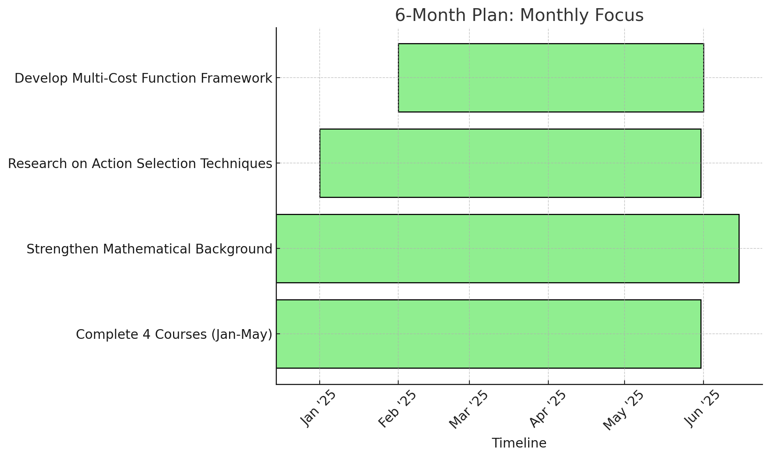

# Visible research output

* Publications:
* Conferences:
* Workshops:

1. **Detailed Report (no page limit): Mandatory**

# References: